CHAPTER 1
INTRODUCTION

Nowadays public areas are monitored by several cameras in order to increase public order and safety. For most applications, trained and experienced human operators can do this monitoring very well. However, watching multiple camera images at the same time is not only too expensive but also practically impossible. Moreover, surveillance video data is currently used only “after the fact” as a forensic tool, thus losing its primary benefit as an active, real-time medium. The goal of visual surveillance is not only to put cameras in the place of human eyes, but also to accomplish the entire surveillance task as automatically as possible. Thus, intelligent visual surveillance (IVS) becomes an active research topic in computer vision.
Detection of foreground objects of interest from a surveillance video sequence is a key step for an intelligent visual surveillance system. In the literature there are various algorithms proposed for object detection. All of these approaches assume that the input images have clear visibility, thus they can achieve satisfying results under clear weather conditions. Unfortunately, this is not always true, such as when videos are taken under bad weather conditions, such as on a foggy day. The image suffers degradation and severe contrast loss. These low-quality images are a nuisance for conventional object detection algorithms.
Similarly, Murk is a thick cloud of tiny water droplets suspended in the atmosphere which obscures visibility. Diverse weather situations such as murk, smoke, rain or snow will cause multifaceted visual effects of spatial or temporal domains in images or video. Such artifacts may appreciably humiliate the performances of outdoor vision systems relying on image/video feature extraction or visual attention modelling such as event detection, object detection, tracking and recognition, scene analysis and classification, image indexing and retrieval. They generally fail to correctly detect objects due to low scene visibility. In order to get clear surveillance frames, enhancing visibility is an

inevitable task. In recent years, as an active research topic in computer vision, considerable work has been done on haze removal techniques.

Unfortunately, most country in the world has an alarming record in number of death/disability due to tremendous number of accidents. Accidents are occurred because of unawareness of the people. Researchers found that 57% of accidents where due to solely driver factors, which include his behavior, decision making ability, reaction speed and alertness. The studies show that the accidents can be avoided if driver was provided with warning message few seconds before so that, they can take some alternative route or be cautious to avoid traffic congestion or accidents.The vehicular adhoc network was adopted to mimic the adhoc nature of highly dynamic network. In this network two vehicles can communicate with each other. For Vehicle safety a new technique can be created. VANET Communication is classified into two different types Vehicle to Vehicle communication and Vehicle to Infrastructure Communication. The vehicle to vehicle communication is a communication between two vehicles (i.e.) one hop communication, such as car to car communication. The vehicle to Infrastructure communication is communication between vehicle and road side Infrastructure. It acts as a multi hop communication. The vehicle to vehicle communication is a system designed to transfer basic safety related with vehicles to provide warning to drivers concerning accidents. The main objective of this system is to alert drivers when he closes to front vehicle. The communication between the vehicles takes place by means of LI-FI. The distance between two vehicles is measured using Ultrasonic sensor. The microcontroller controls the entire circuit and is programmed to notify the driver with a message when the vehicle comes within the Line of sight. There are several obstacles that hinder the safety while driving. The vehicle such as car or buses may break down in middle of the road especially during the night time these becomes a serious obstacle mainly in highways were the roads are not lighted.

The vehicle coming behind may not judge the stationary vehicle and may cause accident; the vehicle coming behind may hit hardly to the back of stationary vehicle and may lead to greater damage. Many scenarios were considered for the design of the system.

First Scenario

Vehicle1 slows down the speedometer senses the speed if lower than the previous speed an Ultrasonic Sensor attached in the bonnet using Doppler-effect is made to sense continuously. When the distance between the two vehicles decreases a warning, message is transferred to back vehicle using the transmitter attached in the front vehicle it is received by the photo-detector attached to the back vehicle so he can take necessary steps to ensure that collision is avoided.

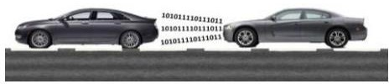

Fig1. First Scenario of Vehicle to Vehicle Communication Using VLC

  - Second Scenario

The major reasons for accidents are due to the negligence of the driver who might be under the influence of alcohol or might be sleeping while driver [6]. The vehicles are interfaced with an Alcohol as well as an Eye-blink sensor to monitor driver. If the driver is under the influence of alcohol or is sleeping this information is transferred to vehicle within the line of sight so vehicle can speed up or allow the vehicle to go ahead without causing any damage.

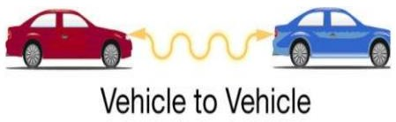

Fig2. Second Scenario of Vehicle to Vehicle Communication Using VLC

1.3 WITHOUT WI-FI OR GPS

Vehicle to vehicle communication system that does not require a tracking global positioning System or even a Wi-Fi or 3G wireless connectivity. We Propose to use Programmable Interface Controller (PIC) sonar which sends 40 KHz short pulse of sound that is undetectable by human ear. The echo of the signal will be detected by micro controller. The distance is calculated by the time require for echo signal to be transmit and receive. Several researches work we will attempt in literature for vehicle to vehicle communication using an advantage of light. As light frequency spectrum is huge, it is beneficial to be adopt in a short-range wireless communication.

1.4 METHODOLOGY

Communication between Vehicle to Vehicle and Ranging System has been proposed by using Spread Spectrum Technique. In this, a vehicle (Vehicle-A) provides the information about distance between target vehicle (Vehicle-B) and vehicles A. However, in this system, only one target vehicle is used in this paper, we also design multi target Communication and Ranging for vehicle to vehicle data transmission System by Using Spread Spectrum Technique. In this system, at the same time vehicles A can communicate with other target vehicles. From computer simulations, When interference signals is exist then we confirmed that this system become effective.Vehicular ad hoc network (VANETs) that means devices have not access point is used for real time application such as (VANETs) can communicate with roadside units(RSU).By this communication provides information about traffic, accurate position of vehicle. For this purpose, number of protocols should be used to get desired output.

1.5 TESTING

Unit Testing:

    - Unit Testing is a method by which individual units of source code are tested to determine if they are fit to use.
    - We are going to implement unit testing for this project.
    - A unit is the smallest testable part of an application. We are going to test each unit or module from code.

Task Testing:

Task Testing is the basic of all kinds of testing related to software. Tn Task Testing we will check whether the system is performing the allocated task correctly or not, if yes well and good if not then test cases will be designed to improve the performance of the system.

Inter-Task Testing:

    - Inter-task Testing basically deals with testing whether the interactions between different modules of the system is properly working, in other words, we can say that inter-task testing deals with testing of interrelationship between modules.
    - In this Folder Locking System, testing is performed for checking the authentication of the user for Candidate Points Identification.

CHAPTER 2 LITERATURE REVIEW

1) Evaluation of Various Digital Image Fog Removal Algorithms AUTHORS: Gagandeep Singh1, Gagandeep Singh
This paper is a review on the various fog removal algorithms. Fog removal otherwise called visibility restoration refers to diverse systems that supposed to lessen or evacuate the degradation that have happened while the digital picture was being acquired. In this paper, various fog removal techniques have been analyzed. It has been shown that each fog removal technique has its own features and drawbacks. The presented methods have neglected the techniques to reduce the noise issue, which is presented in the output images of the existing fog removal algorithms. Not much effort has focused on the integrated approach of the CLAHE and Dark channel prior. The problem of the uneven illuminate has also neglected by the most of the researchers.

Research for Image Haze-Removal Algorithm Using the Dark-Channel Prior Based on Wavelet Transform

AUTHORS: Wu Sijiu, Zhang Haiyan
In this paper, having compared the image haze-removal algorithms for image restoration and image enhancement, the principle of image haze-removal algorithm using dark channel prior is analyzed and discussed. The shortcomings of the algorithm are pointed out. At the same time, image haze-removal algorithm using the dark-channel prior based on wavelet decomposition is proposed. There are three steps included: three channel wavelets transform for the image, image haze-removal algorithm using the dark-channel prior of the low frequency components for dark channel prior and upgrading sharpening for high

frequency components. The experimental results show that the algorithm can improve the resolution of image after image haze-removal and have better performance in detail, but also can effectively reduce the running time, improve the operating speed.

Improving Image Quality in Poor Visibility Conditions Using a Physical Model for Contrast Degradation

AUTHORS: J.P. Oakley ; B.L. Satherley

In daylight viewing conditions, image contrast is often significantly degraded by atmospheric aerosols such as haze and fog. This paper introduces a method for reducing this degradation in situations in which the scene geometry is known. Contrast is lost because light is scattered toward the sensor by the aerosol particles and because the light reflected by the terrain is attenuated by the aerosol. This degradation is approximately characterized by a simple, physically based model with three parameters. The method involves two steps: first, an inverse problem is solved in order to recover the three model parameters; then, for each pixel, the relative contributions of scattered and reflected flux are estimated. The estimated scatter contribution is simply subtracted from the pixel value and the remainder is scaled to compensate for aerosol attenuation. This paper describes the image processing algorithm and presents an analysis of the signal-to-noise ratio (SNR) in the resulting enhanced image. This analysis shows that the SNR decreases exponentially with range. A temporal filter structure is proposed to solve this problem. Results are presented for two image sequences taken from an airborne camera in hazy conditions and one sequence in clear conditions. A satisfactory agreement between the model and the experimental data is shown for the haze conditions. A significant improvement in image quality is demonstrated when using the contrast enhancement algorithm in conjunction with a temporal filter.

- Automatic Single-Image-Based Rain Streaks Removal via Image Decomposition AUTHORS: Li-Wei Kang ; Chia-Wen Lin ; Yu-Hsiang Fu
Rain removal from a video is a challenging problem and has been recently investigated extensively. Nevertheless, the problem of rain removal from a single image was rarely studied in the literature, where no temporal information among successive images can be exploited, making the problem very challenging. In this paper, we propose a single-image- based rain removal framework via properly formulating rain removal as an image decomposition problem based on morphological component analysis. Instead of directly applying a conventional image decomposition technique, the proposed method first decomposes an image into the low- and high-frequency (HF) parts using a bilateral filter. The HF part is then decomposed into a “rain component” and a “nonrain component” by performing dictionary learning and sparse coding. As a result, the rain component can be successfully removed from the image while preserving most original image details. Experimental results demonstrate the efficacy of the proposed algorithm.

- Fast Single Image Rain Removal via a Deep Decomposition-Composition Network AUTHORS: Siyuan LI, Wenqi Ren, Jiawan Zhang, Jinke Yu, Xiaojie Guo
Rain effect in images typically is annoying for many multimedia and computer vision tasks. For removing rain effect from a single image, deep leaning techniques have been attracting

considerable attentions. This paper designs a novel multi-task leaning architecture in an end-to-end manner to reduce the mapping range from input to output and boost the performance. Concretely, a decomposition net is built to split rain images into clean background and rain layers. Different from previous architectures, our model consists of, besides a component representing the desired clean image, an extra component for the rain layer. During the training phase, we further employ a composition structure to reproduce the input by the separated clean image and rain information for improving the quality of decomposition. Experimental results on both synthetic and real images are conducted to reveal the high-quality recovery by our design, and show its superiority over other state- of-the-art methods. Furthermore, our design is also applicable to other layer decomposition tasks like dust removal. More importantly, our method only requires about 50ms, significantly faster than the competitors, to process a testing image in VGA resolution on a GTX 1080 GPU, making it attractive for practical use.

“Cluster-based location routing algorithm for inter-vehicle communication,”

R. A. Santos, R. Edwards, and A. Edwards, in Vehicular Technology Conference, 2004. VTC2004-Fall. 2004 IEEE 60th, vol. 2, Sept 2004, pp. 914–918 Vol. 2.
We consider a motorway environment with associated high mobility and compare and contrast position-based and non-position-based routing strategies in reactive ad-hoc protocols. The performances of dynamic source routing (DSR) and ad-hoc on-demand distance vector routing (AODV), for non-positional algorithms, and cluster-based location routing (CBLR), for positional algorithms, are considered. First, for small-scale networks, we have validated our simulation model with the results of a test bed. Then, through simulations, our model is compared with two prominent reactive routing algorithm models for large-scale networks: AODV and DSR. Finally, vehicle mobility on a motorway using

a microscopic traffic model developed in OPNET is used to evaluate average route discovery (RD) time, end-to-end delay (EED), routing load, routing overhead, overhead, and delivery ratio.

“An adaptable mobility aware clustering algorithm in vehicular networks,”

M. Morales, C. seon Hong, and Y. C. Bang, in Network Operations and Management Symposium (APNOMS), 2011 13th Asia-Pacific, Sept 2011, pp. 1–6.
The forthcoming Intelligent Transportation System aims to achieve safety and productivity in transportation using vehicular ad hoc networks (VANETs) to support the communications system required. Currently, some clustering approaches have been proposed to improve the performance of VANETs due to their dynamic nature, high scalability and load balancing results. However, the host mobility and the constantly topology change continue to be main problems of this technique due to the lack of models which represent the vehicular behavior and the group mobility patterns. Therefore, we propose an Adaptable Mobility-Aware Clustering Algorithm based on Destination positions (AMACAD) to accurately follow the mobility pattern of the network prolonging the cluster lifetime and reducing the global overhead. In an effort to show the efficiency of AMACAD, a set of simulation was executed. The obtained results reveal an outstanding performance in terms of the lifetime of the cluster heads, lifetime of the members and the re-affiliation rate under varying speeds and transmission ranges.

CHAPTER 3 PROJECT DESCRPTION

3.1 Existing System:
Poor visibility becomes a major problem for most outdoor vision applications. Bad weather caused by atmospheric particles, such as fog, haze, etc., may significantly reduce the visibility and distort the colors of the scene. This is due to the following two scattering processes, (i) light reflected from the object surface is attenuated due to scattering by particles; and (ii) some direct light flux is scattered toward the camera. These effects result in the contrast reduction increases with the distance. In computer vision, the atmospheric scattering model is usually used to describe the formation of a foggy or hazy image. Almost all established methods are based on this model. Some of them require multiple input images of a scene; e.g., images taken either under different atmospheric conditions, or with different degrees of polarization. Another methods attempt to remove the effects of fog from a single image using some form of depth information either from terrain models or user inputs. In practical applications, it is difficult to achieve these conditions so such approaches are restricted. The very latest defogging methods are able to defog single images by making various assumptions about the depth or colors in the scene.

Disadvantages:

- It makes drivers to drive vehicle cautiously
- Increase the travel times
- Significantly reduce road visibility

3.2 Proposed System:
The proposed system uses camera to get the foggy view of the road. The video is preprocessed and it is cleared without fog. Using the MATLAB, we are detecting the objects presents in the road view. If the object is detected then it is given as input to the micro controller. Then the intimation will be given to the driver as voice playback. During foggy condition in the road if any vehicle goes near to another then both vehicles will communicate using V2X communication. The vehicle which is going in front will intimate the rear vehicle through WSN. It will be intimated as voice output. Using this system vehicle accidents can be prevented.

Advantages:

- Driver get view of the road
- Reduces the travel times
- Increase the visibility of road and prevent accidents














3.3 Block Diagram: MATLAB Section:
VIDEO TO
FRAME
IMAGE
PREPROCESSING
WLS FILTER
MICRO
CONTROLLER
HDR TONE
MAPPING
UART
OUTPUT
OBJECT
DETECTION
IMAGE WITHOUT
FOGG

INPUT FOGGY
VIDEO

DATA SET

Car Section 1:
VOICE PLAYBAC
VOICE PLAYBACK
UART

Computer
WSN

MICRO CONTROLLER
POWER

LCD

Car Section 2:

MICRO CONTROLLER
LCD

POWER SUPPLY

WSN
UART

3.4 Hardware Requirements:
- UART
- Microcontroller Atmega328
- Power Supply Unit
- Voice IC
- Speaker
- WSN

3.5 Software Requirements:
- Embedded C
- Arduino IDE
- MATLAB

3.6 VIDEO PROCESSING

EXISTING SYSTEM:
- In existing, they proposed murk/haze removal by using CLAHE and object
detection using Curvelet Transform.
- Initially the RGB image is converted to gray scale image.
- The gray scale image is then filtered using median filter.
- The filtered image is enhanced using CLAHE.
- Finally, the enhanced image is segmented by Curvelet Transform.

DISADVANTAGES OF EXISTING SYSTEM:

- In existing less amount of haze/murk removal in image is proposed.
- The rate of detection accuracy was less.
- And distance calculation is not implemented in existing for alert the driver.

PROPOSED SYSTEM:

The proposed model follows dictionary learning, bilateral and guided filter for enhancement and saliency map for object detection. It consists of five steps.
Step 1: Collecting the test images from public database.

Step 2: Image decomposition is proposed in fog image. In image decomposition, image is decomposed into low frequency part and high frequency part (details layers) based on bilateral filter.
Step 3: After that, dark channel prior based fog removal implements in original fog image; details layers (HF part) enhanced using guided filter for restore the dehazed image with initial fog removed image.
Step 4: The enhanced image is segmented and the object are detected based on saliency map. And also detected object or obstacles are classified based on the statistical feature i.e. Human, Vehicle and Animal.
Step 5: To avoid the accident distance was calculated between the detected object and camera mounted vehicle. Finally based on the distance, some alert system provided to drivers.

ADVANTAGES OF PROPOSED SYSTEM:

- The high level of performance occurs in removal of rain and haze.
- The rate of detection accuracy is high.
- The distance calculation is implemented to prevent the accident.

CHAPTER 4

IMPLEMENTATION

4.1 Image Acquisition:

  - Testing videos are acquired from Gallery.

Image Enhancement:
  - In this stage, image is enhanced interns of fog removal by image decomposition, fog removal and detail part extraction/restoration. The aim of image decomposition is to decompose the image I into its low frequency part LF and its high frequency part HF, namely, I = LF + HF. Image decomposition process done by using our novel method. The method is bilateral filter that is used for decompose of image in image decomposition.
  - Bilateral filter first extracts the base layer that is called as low frequency part image (smoothed image). It’s almost less fog free image but usually blurred, while HF contains details of the image. The detail layer or high frequency part image obtained as HF = I – LF. After that guided filter is proposed for enhance the detail part of image.

  - Next, initial fog removal is implemented by using dark channel prior. Dark channel prior is used for extract the transmission map and guided filter is proposed for smooth the transmission map. Finally, we restore dehazed image by combining of smoothed transmission map and enhanced detail part.

4.3 Obstacle Detection:
  - In this step, obstacles are detected by using hyper graph saliency map.
  - Thus, enhanced image is segmented and then obstacle was detected. Finally, statistical feature is evaluated for classify the detected obstacle i.e. human, animal and vehicle.

4.4 Distance Calculation:
  - After obstacle detection, distance calculation is performed between detected obstacle and testing camera mounted vehicle. Then distance value is converted pixel into meters.
  - Based the distance of the obstacle from the camera mounted vehicle, three kinds of messages (indication) are given to the driver i.e. obstacle very near, if obstacle is very near to the vehicle, obstacle little far, if the obstacle is little far from the vehicle and very far, if the obstacle is very far and at a safe distance from the vehicle.

4.5 WORKING OF HAZE REMOVAL:
We propose a novel prior -dark channel prior, for single image haze removal. The dark channel prior is based on the statistics of haze-free outdoor images. We find that, in most of the local regions which do not cover the sky, it is very often that some pixels (called” dark pixels”) have very low intensity in at least one color (RGB) channel. In the haze image, the intensity of these dark pixels in that channel is mainly contributed by the air light. Therefore, these dark pixels can directly provide accurate estimation of the haze’s transmission. Combining a haze imaging model and a guided filter method, we can recover a hi-quality haze-free image and produce a good depth map (up to a scale). Our approach is physically valid and is able to handle distant objects even in the heavy haze image. We do not rely on significant variance on transmission or surface shading in the input image. The result contains few halo artifacts.

4.6 WORKING OF OBJECT DETECTION:
The simplest method to obtain the salient object region is by thresholding the saliency map to get a binary mask. In order to accurately detect salient objects from saliency maps, image segmentation result is combined with the saliency map.

CHAPTER 5
SYSTEM DESIGN

5.1 DATA FLOW DIAGRAM:

- The DFD is also called as bubble chart. It is a simple graphical formalism that can be used to represent a system in terms of input data to the system, various processing carried out on this data, and the output data is generated by this system.
- The data flow diagram (DFD) is one of the most important modeling tools. It is used to model the system components. These components are the system process, the data used by the process, an external entity that interacts with the system and the information flows in the system.
- DFD shows how the information moves through the system and how it is modified by a series of transformations. It is a graphical technique that depicts information flow and the transformations that are applied as data moves from input to output.
- DFD is also known as bubble chart. A DFD may be used to represent a system at any level of abstraction. DFD may be partitioned into levels that represent increasing information flow and functional detail.

Image Acquisition

Image Enhancement

Obstacle Detection & Classification

Distance Calculation

Alert System

5.2 UML DIAGRAM

UML stands for Unified Modeling Language. UML is a standardized general- purpose modeling language in the field of object-oriented software engineering. The standard is managed, and was created by, the Object Management Group.
The goal is for UML to become a common language for creating models of object- oriented computer software. In its current form UML is comprised of two major components: A Meta-model and a notation. In the future, some form of method or process may also be added to; or associated with, UML.
The Unified Modeling Language is a standard language for specifying, Visualization, Constructing and documenting the artifacts of software system, as well as for business modeling and other non-software systems.
The UML represents a collection of best engineering practices that have proven successful in the modeling of large and complex systems.
The UML is a very important part of developing objects-oriented software and the software development process. The UML uses mostly graphical notations to express the design of software projects.

GOALS:

The Primary goals in the design of the UML are as follows:
- Provide users a ready-to-use, expressive visual modeling Language so that they can develop and exchange meaningful models.
- Provide extendibility and specialization mechanisms to extend the core concepts.
- Be independent of particular programming languages and development process.
- Provide a formal basis for understanding the modeling language.
- Encourage the growth of OO tools market.

- Support higher level development concepts such as collaborations, frameworks, patterns and components.
- Integrate best practices.

5.3USE CASE DIAGRAM:
A use case diagram in the Unified Modeling Language (UML) is a type of behavioral diagram defined by and created from a Use-case analysis. Its purpose is to present a graphical overview of the functionality provided by a system in terms of actors, their goals (represented as use cases), and any dependencies between those use cases. The main purpose of a use case diagram is to show what system functions are performed for which actor. Roles of the actors in the system can be depicted.


OUTPUT
INPUT

Image Acquisition
Image Enhancement
Obstacle Detection &
Classification
Distance Calculation
Alert System

5.4 CLASS DIAGRAM:
In software engineering, a class diagram in the Unified Modeling Language (UML) is a type of static structure diagram that describes the structure of a system by showing the system's classes, their attributes, operations (or methods), and the relationships among the classes. It explains which class contains information.

Input
Image Acquisition
Image Enhancement ( )

Output
Obstacle Detection & Classification
Distance calculation
Alert System ( )

5.5 SEQUENCE DIAGRAM:
A sequence diagram in Unified Modeling Language (UML) is a kind of interaction diagram that shows how processes operate with one another and in what order. It is a construct of a Message Sequence Chart. Sequence diagrams are sometimes called event diagrams, event scenarios, and timing diagrams.

Input

Image Acquisition
Output

Image Enhancement
Obstacle Detection & Classification
Distance Calculation
Alert System

5.6 ACTIVITY DIAGRAM:
Activity diagrams are graphical representations of workflows of stepwise activities and actions with support for choice, iteration and concurrency. In the Unified Modeling Language, activity diagrams can be used to describe the business and operational step-by- step workflows of components in a system. An activity diagram shows the overall flow of control.

Image Acquisition
Image Enhancement
Obstacle Detection &
Classification
Distance Calculation
Alert System

CHAPTER 6

SYSTEM STUDY

6.1 FEASIBILITY STUDY

The feasibility of the project is analyzed in this phase and business proposal is put forth with a very general plan for the project and some cost estimates. During system analysis the feasibility study of the proposed system is to be carried out. This is to ensure that the proposed system is not a burden to the company. For feasibility analysis, some understanding of the major requirements for the system is essential.

Three key considerations involved in the feasibility analysis are

- ECONOMICAL FEASIBILITY
- TECHNICAL FEASIBILITY
- SOCIAL FEASIBILITY

6.2 ECONOMICAL FEASIBILITY
This study is carried out to check the economic impact that the system will have on the organization. The amount of fund that the company can pour into the

research and development of the system is limited. The expenditures must be justified. Thus, the developed system as well within the budget and this was achieved because most of the technologies used are freely available. Only the customized products had to be purchased.

6.3 TECHNICAL FEASIBILITY
This study is carried out to check the technical feasibility, that is, the technical requirements of the system. Any system developed must not have a high demand on the available technical resources. This will lead to high demands on the available technical resources. This will lead to high demands being placed on the client. The developed system must have a modest requirement, as only minimal or null changes are required for implementing this system.

6.4 SOCIAL FEASIBILITY
The aspect of study is to check the level of acceptance of the system by the user. This includes the process of training the user to use the system efficiently. The user must not feel threatened by the system, instead must accept it as a necessity. The level of acceptance by the users solely depends on the methods that are employed to educate the user about the system and to make him familiar with it. His level of confidence must be raised so that he is also able to make some constructive criticism, which is welcomed, as he is the final user of the system.

CHAPTER 7

SYSTEM TESTING

The purpose of testing is to discover errors. Testing is the process of trying to discover every conceivable fault or weakness in a work product. It provides a way to check the functionality of components, sub-assemblies, assemblies and/or a finished product It is the process of exercising software with the intent of ensuring that the
Software system meets its requirements and user expectations and does not fail in an unacceptable manner. There are various types of test. Each test type addresses a specific testing requirement.

7.1 TYPES OF TESTS

Unit Testing
Unit testing involves the design of test cases that validate that the internal program logic is functioning properly, and that program inputs produce valid outputs. All decision branches and internal code flow should be validated. It is the testing of individual software units of the application .it is done after the completion of an individual unit before integration. This is a structural testing, that relies on knowledge of its construction and is invasive. Unit tests perform basic tests at component level and test a specific business process, application, and/or system configuration. Unit tests ensure that each unique path of a business process performs accurately to the documented specifications and contains clearly defined inputs and expected results.

Integration Testing
Integration tests are designed to test integrated software components to determine if they actually run as one program. Testing is event driven and is more concerned with the basic outcome of screens or fields. Integration tests demonstrate that although the components were individually satisfaction, as shown by successfully unit testing, the combination of components is correct and consistent. Integration testing is specifically aimed at exposing the problems that arise from the combination of components.

Functional test
Functional tests provide systematic demonstrations that functions tested are available as specified by the business and technical requirements, system documentation, and user manuals.

Functional testing is centered on the following items:

Valid Input : identified classes of valid input must be accepted. Invalid Input : identified classes of invalid input must be rejected. Functions : identified functions must be exercised.
Output : identified classes of application outputs must be exercised. Systems/Procedures: interfacing systems or procedures must be invoked.

Organization and preparation of functional tests is focused on requirements, key functions, or special test cases. In addition, systematic coverage pertaining to identify Business process flows; data fields, predefined processes, and successive processes must be considered for testing. Before functional testing is complete, additional tests are identified and the effective value of current tests is determined.

System Test
System testing ensures that the entire integrated software system meets requirements. It tests a configuration to ensure known and predictable results. An example of system testing is the configuration-oriented system integration test. System testing is based on process descriptions and flows, emphasizing pre-driven process links and integration points.

White Box Testing
White Box Testing is a testing in which in which the software tester has knowledge of the inner workings, structure and language of the software, or at least its purpose. It is purpose. It is used to test areas that cannot be reached from a black box level.

Black Box Testing
Black Box Testing is testing the software without any knowledge of the inner workings, structure or language of the module being tested. Black box tests, as most other kinds of tests, must be written from a definitive source document, such as specification or requirements document, such as specification or requirements document. It is a testing in which the software under test is treated, as a black box. You cannot “see” into it. The test provides inputs and responds to outputs without considering how the software works.

Unit Testing:
Unit testing is usually conducted as part of a combined code and unit test phase of the software lifecycle, although it is not uncommon for coding and unit testing to be conducted as two distinct phases.

Test Strategy and approach
Field testing will be performed manually and functional tests will be written in
detail.

Test objectives
  - All field entries must work properly.
  - Pages must be activated from the identified link.
  - The entry screen, messages and responses must not be delayed.

Features to be tested
  - Verify that the entries are of the correct format
  - No duplicate entries should be allowed
  - All links should take the user to the correct page.

Integration Testing
Software integration testing is the incremental integration testing of two or more integrated software components on a single platform to produce failures caused by interface defects.

The task of the integration test is to check that components or software applications,
e.g. components in a software system or – one step up – software applications at the company level – interact without error.

Test Results
All the test cases mentioned above passed successfully. No defects encountered.

Acceptance Testing
User Acceptance Testing is a critical phase of any project and requires significant participation by the end user. It also ensures that the system meets the functional requirements.

7.2 Test Results
All the test cases mentioned above passed successfully. No defects encountered.

7.3 OUTPUT RESULTS
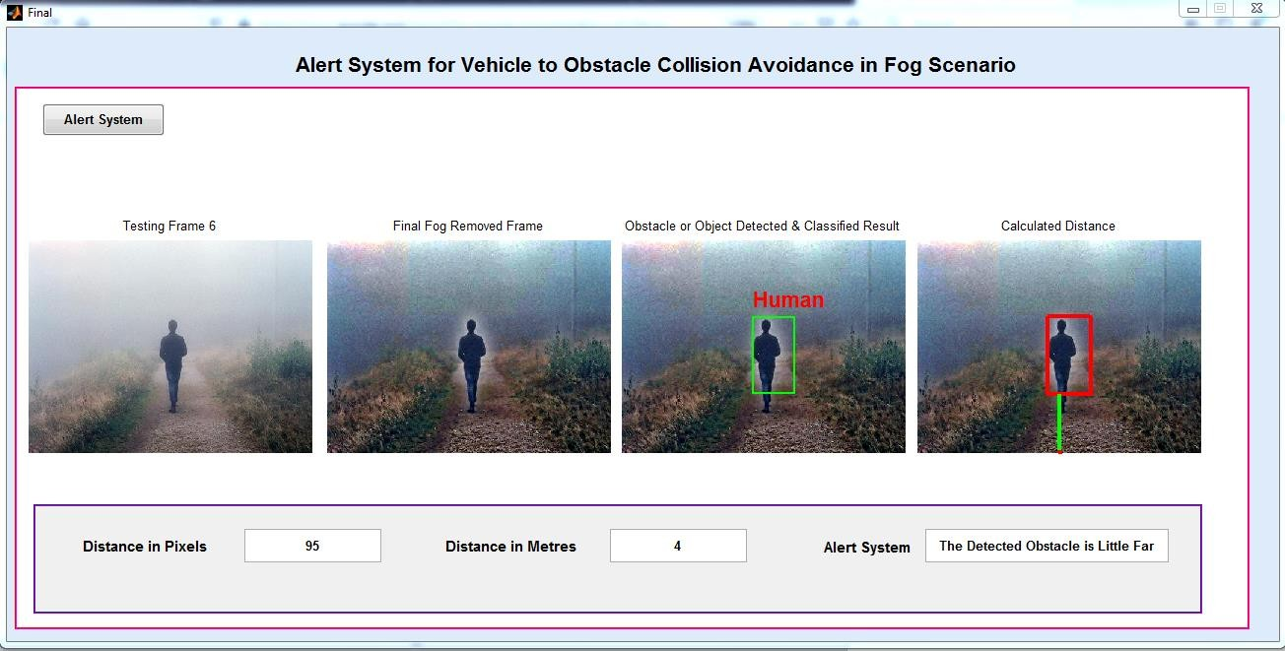
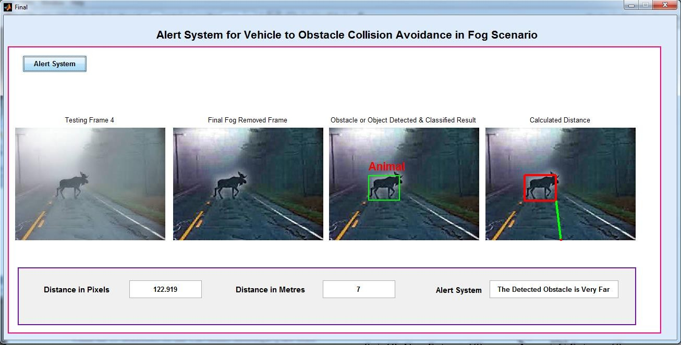

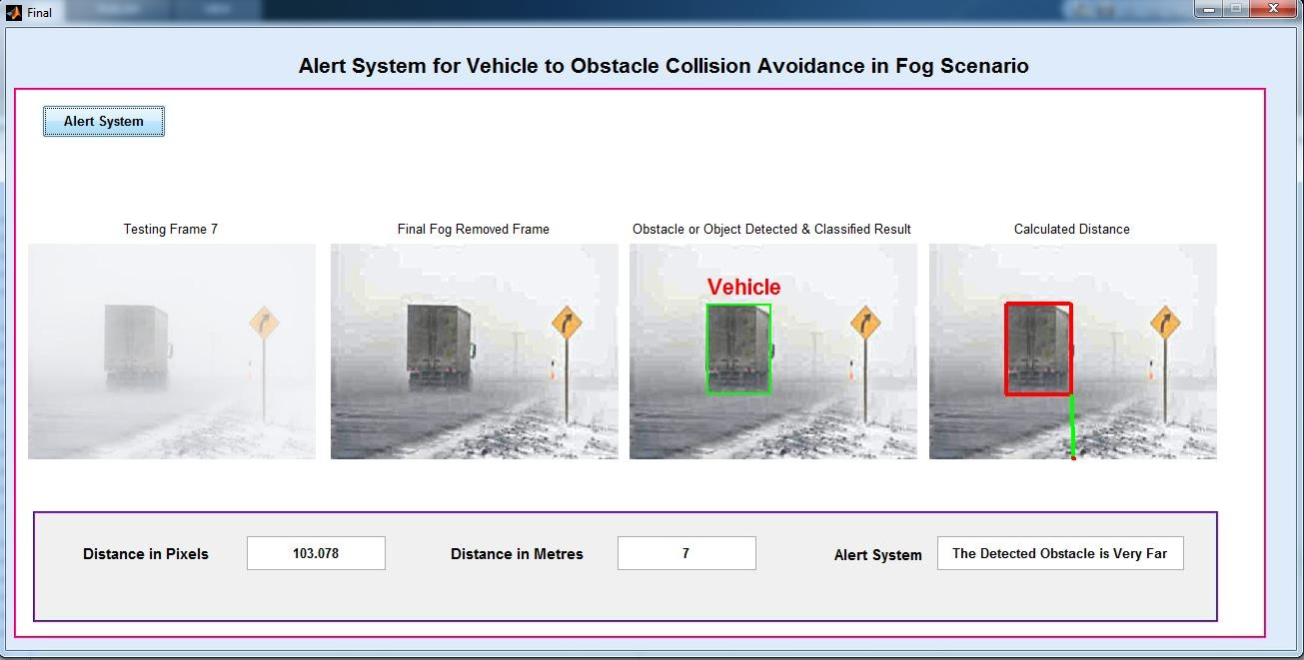

CHAPTER 8

CONCLUSION

The image enhancement has become one of the active areas in the field of image processing. In this project the fog images are filtered using Bilateral Filter, Dark Channel Prior and Guided Filter. Then objects or obstacles are yet to be extracted from the enhanced fog image based on the Saliency Map. Finally, distance is calculated between detected object and camera mounted vehicle. Thus, efficient automatic vehicle detection and a warning system can help drivers in reducing the number of accidents occurring between the one vehicle and the any obstacles on roads and highways.

REFERENCES

- Ambuj Kumar and Rajendra Prasad Nayak,” An Efficient Group-Based Safety Message Transmission Protocol for VANET”, IEEE International Conference on communication and signal processing, April 3-5,2013 India, pp. 1 -4
- Sok-Ian Sou and Ozan. Tonguz” Enhancing VANET Connectivity through Roadside Units on Highway”, IEEE transaction on Vehicular Technology, Vol. 60, No 8, October 2011, pp..3586-3602.
- Seh Chun Ng, Wuxiong Zhang, Yu Zhang, Yang Yang “Analysis of Access and Connectivity Probablities in Vehicular Relay Network” IEEE journal ON selected Areas in Communication, Vol. 29, No.3, March 2011, pp. 140-150.
- A. Boukerche et al., “Vehicular Ad Hoc Networks: a new challenge for localization- based systems,” Computer Communications, ScienceDirect, 2008, pp. 1-12.
- T. H. M. A. Y. K. K. K. Isamu Takai, “Optical Vehicle to-Vehicle Communication System Using LED Transmitter and Camera Receiver,” IEEE Photonics Journal, Vol. 6, No. 5, October 2014, pp. 7902513- 7902513.
- Yuichi Tanakat, Shinichirou Haruyamat, Masao Nakagawat “Wireless Optical Transmissions with white colored LED for Wireless Home Links”, Department of Electrical Engineering, Faculty of Science and Technology, Keio University.
- Samreen.N. Shaikh, Dr. S.R. Patil, “A Robust Broadcast Scheme for Vehicle to Vehicle communication”,2016 Conference on Advances in Signal Processing (CASP) Cummins College of Engineering for Women, Pune. Jun 9-11,2016.

- Kiyoshi MIZUI, Masao NAKAGAWA, “Vehicle-to-Vehicle Multi Target Communication and Ranging System Using Spread Spectrum Technique”.
- Lina Altoaimy, Imad Mahgoub, and Monika Rathod, “Weighted Localization in Vehicular Ad Hoc Networks Using Vehicle-to Vehicle Communication”
- Alin-M. Cailean, Barthélemy Cagneau, Luc Chassagne, Suat Topsu, “Design and implementation of a visible light communications system for vehicle applications”, November 2013.
- Shubham Chatterjee, Shalabh Agarwal, “Scope and Challenges in Light Fidelity (LiFi) Technology in Wireless Data Communication”, June 2015.
- Akshata msonnad, anjana gopan, “Recent advancements in li-fi technology”, Dec- 2013
- Aman Sodhi, Jeslin Johnson, “Light Fidelity (LI-FI) - The Future of Visible Light Communication”, March-April 2015. Mehboob raza haider, manoj mdongre, “Vehicle to vehicle communication using visible light communication technology”.
- Ravi Prakash, Prachi Agarwal, “The New Era of Transmission and Communication Technology: Li-Fi (Light Fidelity) LED & TED Based Approach”, February 2014.
- R. Karthika1, S. Balakrishnan, “Wireless Communication using LiFi Technology”, March 2015.
- Riccardo Scopigno, Alessia Autolitano, “The Potential Benefits of On-Board Li-Fi for the Cooperation among Vehicles”.

